Merge Conflict Resolution

Objective
To understand how merge conflicts occur and how they are resolved manually.

Create Conflict Branch
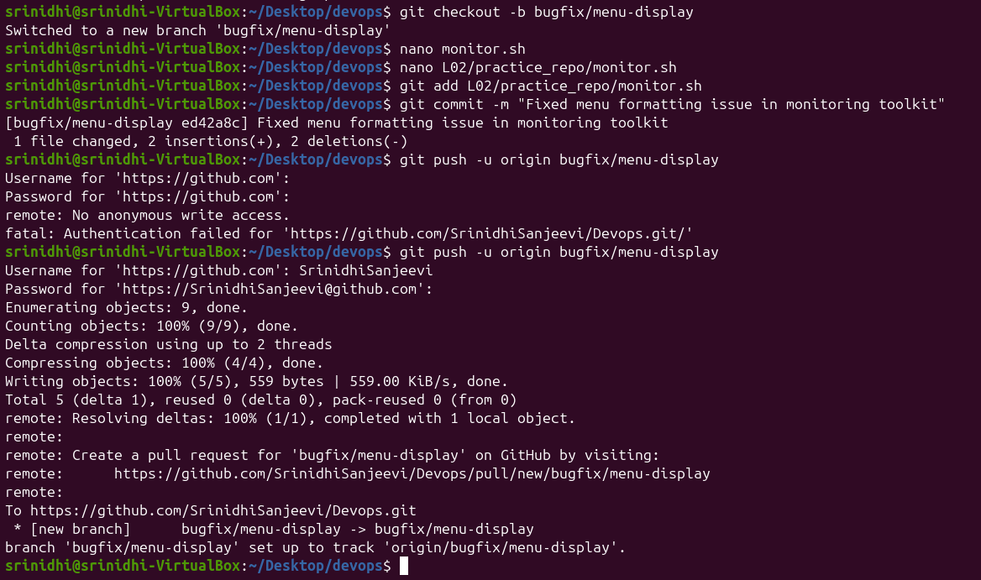

Command
git checkout -b feature/conflict-demo

Purpose
Created a branch to simulate conflicting changes.

Modify Same File
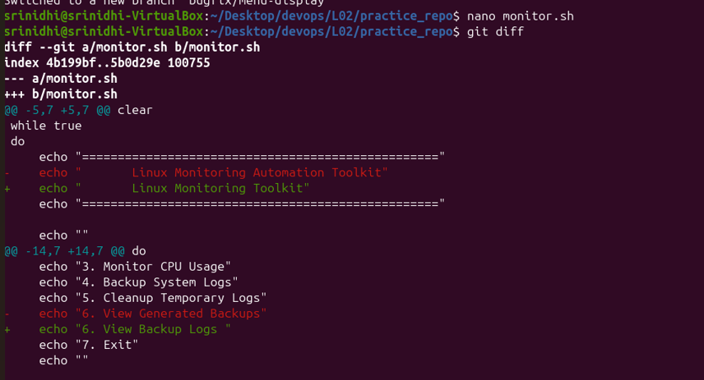

Purpose
The same section of monitor.sh was modified in:
- main branch
- feature/conflict-demo branch
This creates a conflict during merge.

Merge Conflict Occurred
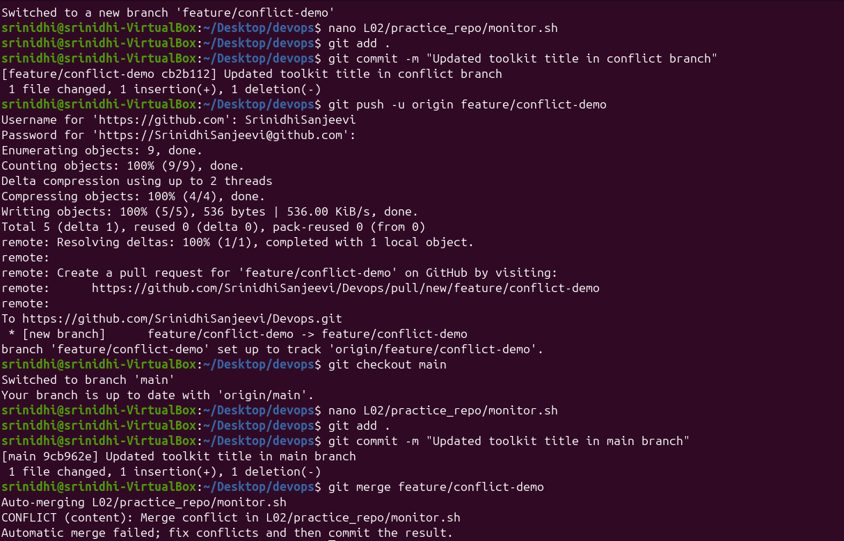

Command
git merge feature/conflict-demo

Output
CONFLICT (content):
Merge conflict in monitor.sh

Purpose
Git cannot automatically determine which changes to keep.

Conflict Markers
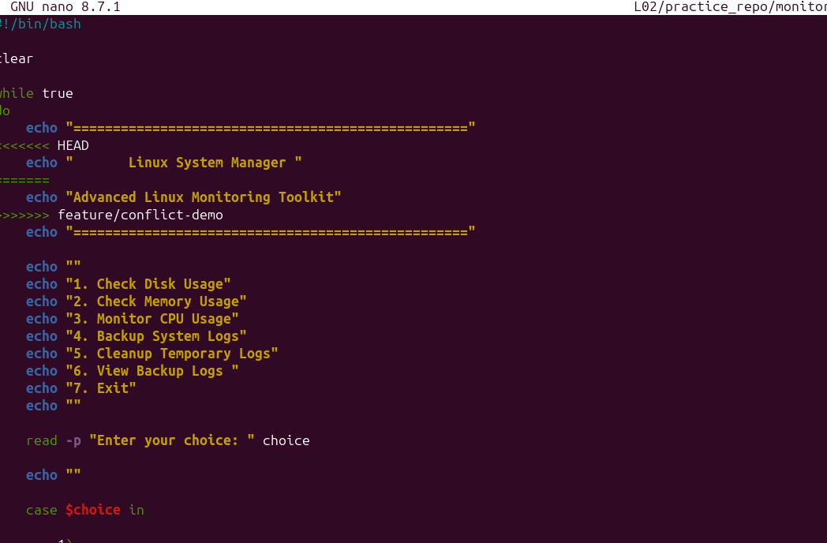

Explanation
Git inserts markers:
<<<<<<< HEAD
Current branch code
=======
Incoming branch code
>>>>>>> feature/conflict-demo

This screenshot shows the merge conflict markers automatically inserted by Git when the same lines were modified in two different branches. The conflict was manually reviewed and resolved by choosing the appropriate code and removing the conflict markers.

Meaning
Marker | Description
<<<<<<< HEAD | Current branch changes
======= | Separator
>>>>>>> | Incoming branch changes

Resolve Conflict
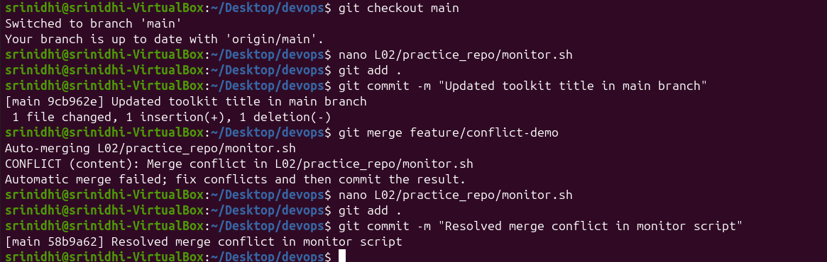

Commands
git add monitor.sh
git commit -m "Resolved merge conflict in monitor script"

Purpose
After manually editing the file:
- Stage resolved file
- Commit final version

Outcome
- Successfully identified, analyzed, and resolved a Git merge conflict by manually editing conflicting code sections and completing the merge process.

